What to look for when Buying Cattle:
- Check registration information. This would also include checking proper brands and making sure they match the papers. Animals that are not branded are not registered.
- If shopping for a bull, a semen test for fertility is a must.
- The overall soundness of the bull should be examined, to ensure the bull can cover his cows.
- If the bull is old enough to have offspring, look at them. This will give you some idea of their production.
- If shopping for a cow, look over her calving record. Make sure she has one! Heifers can and should be bred to calve in their second year.
- Examine udder soundness on cows. Check for teat size, functionality in all the quarters. If teats are large while the cow is not lactating, they could become extremely large while lactating, making it hard or impossible for the calf to nurse. They can also lead to mastitis, an infection in the udder.
- Ask for current breeding status on cows/heifers. If purchasing a bred animal, it is recommended to have preg status verified by a vet prior to taking possession of animal. This protects the buyer and seller.
- Ask about vaccinations and parasite control.
- If traveling with cattle over state lines, be sure the seller is able to complete health paperwork to meet your home states requirements.
- Check the animal’s temperament! Watch for high headed flight behavior, or for aggressive mean behavior. These traits can be very challenging for a new or inexperienced cattle owners.
Registration/Record keeping Tips

- When registering calves born on your ranch the first step is branding them with a holding brand and private herd numbers.
- Call the TLBAA office and get your HORNS account set up!
- HORNS is great for registering and transferring your animals. It also has several recordkeeping options for your animals.
- If transfers or registrations are done on HORNS make sure you choose the correct payment option for your situation. They will NOT be completed until payment is made.
- Transferring on HORNS will require you to still mail in your copy of the registration otherwise you will be charged for a duplicate.
- According to the TLBAA bylaws it is the responsibility of the SELLER to transfer animals.
- Selling/transferring to new breeders you will need to work with the TLBAA Office to start a promotional membership.
- Keep and maintain a herd book. In this book record EVERYTHING!!!! Keep track of EXACT dates of which bull is in the pasture and covering cows. Record heat dates and birth dates on calves. You can’t keep enough records about your herd.
- For personal preference we keep our pedigrees in a 3 ring binder with the slip in clear plastic sheets.
- Its also nice to keep a photo with the pedigree just for reference.
- I really like the TLBAA calendar for recording heat dates. It also gives you a rough due date!! This will help you transfer your breeding information to your herd book every year.

FIRST TIME BUYERS CHECKLIST
The following articles are sourced from the Texas Longhorn Roundup (www.longhornroundup.com/educational) which is a great source of information on Texas Longhorn Cattle. For additional information please visit their website!

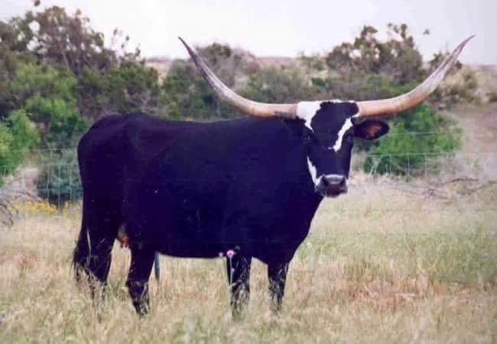
The following is a checklist of some basic things to keep in mind when evaluating cattle that you are thinking about purchasing. These may seem like simple and obvious things that would not be easily over looked. But they are when a buyer is not focused on the overall quality of the animal but rather on one trait. First time buyers and sometimes even experienced buyers will lose focus of the overall quality of an animal. In most cases it is the amount of horn that overwhelms the buyer and makes them lose focus. In some instances I have seen a buyer overlook a major genetic defect because the animal was young and had 80” inches tip-to-tip. If you want to be taken seriously and be involved in this breed for a long period of time you will not want to overlook genetic defects just because the animal has a lot of horn. Horns alone are for the “collector”….the total package animal is for the serious Longhorn breeder. An educated buyer is one that will be happier and more profitable with his purchases.
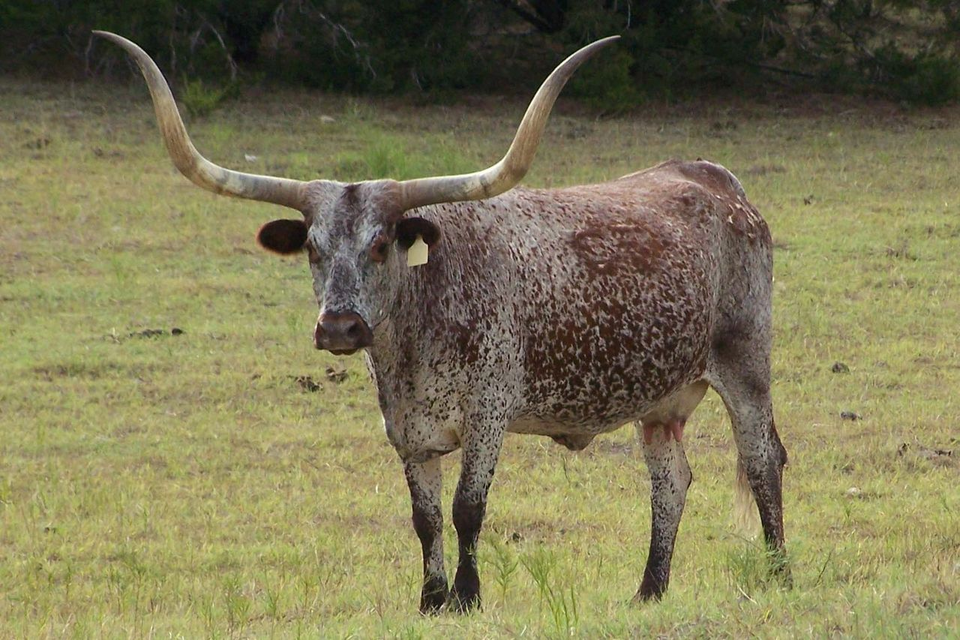
Functionality of an Animal
- Does it have a correct bovine structure?
- Good top line? Easy movement in hips and shoulders?
- Is it sound on its feet, legs and joints? No swelling in the joints? Can the animal move and travel well and easily?
- Mouth and jaw – Is the mouth and jaw set straight and correct? A crooked nose, mouth and/or jaw will make it more difficult for the animal to forage.
These are important to the overall health and well-being of the animal. If the animal is structurally unsound it will have problems making good use of forage and pasture. Bulls with structural problems will have difficulty in keeping up with the cow herd, thus they will not be able to service the cows.
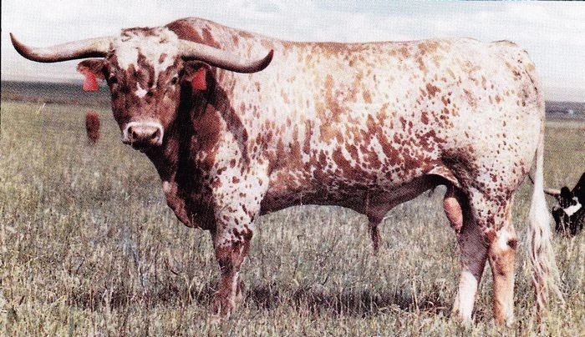
Reproduction
Bulls – Does he have two evenly developed testicles, hanging straight without any signs of a twist? Does he have a normal size sheath and penis opening? Swelling around the opening could indicate an injury or infection.
Females – Does her reproductive area look normal for her age? Does she have a calf at side? Is she palpated bred or just exposed for a long period of time? Under development (looking like a virgin heifer) on an older female that should have had a calf or two could indicate a possible breeding problem.
Ask the seller about production history. Most will be more than willing to provide that information.
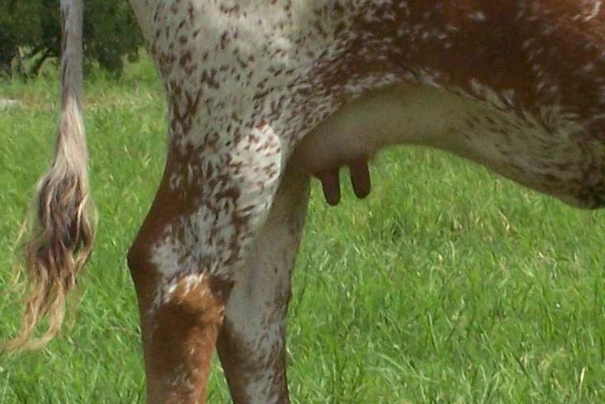
Udder – Is the udder functional? This is a must! If she can’t raise a fat and healthy calf, she is useless! If she has a calf at side it will give you some idea as to the quality of her udder.
Body Condition – Is the animal overly fat? Is the animal extremely thin? Each one of these body conditions could indicate possible problems. An overly fat animal could be a poor or non-breeder. An extremely thin animal could just be a hard keeper or it could indicate several possible problems, some of which are correctable. A couple of these would be coming from poor range or pasture with poor nutrition or the animal needs treatment for parasites. Numerous medical reasons could be the cause of poor body condition and some could be severe.
Pedigree – Is the pedigree of proven genetics? In order to know the quality of the pedigree…Do Your Homework. Study pedigrees in sale catalogs, attend sales as a spectator, visit websites and ask questions. Often the cattle that an individual likes or is drawn to will have similar bloodlines. While studying pedigrees and bloodlines keep in mind that the most advertised (bulls and cows) pedigrees are not always the best or most proven. They just happen to be owned by someone who can afford to advertise.
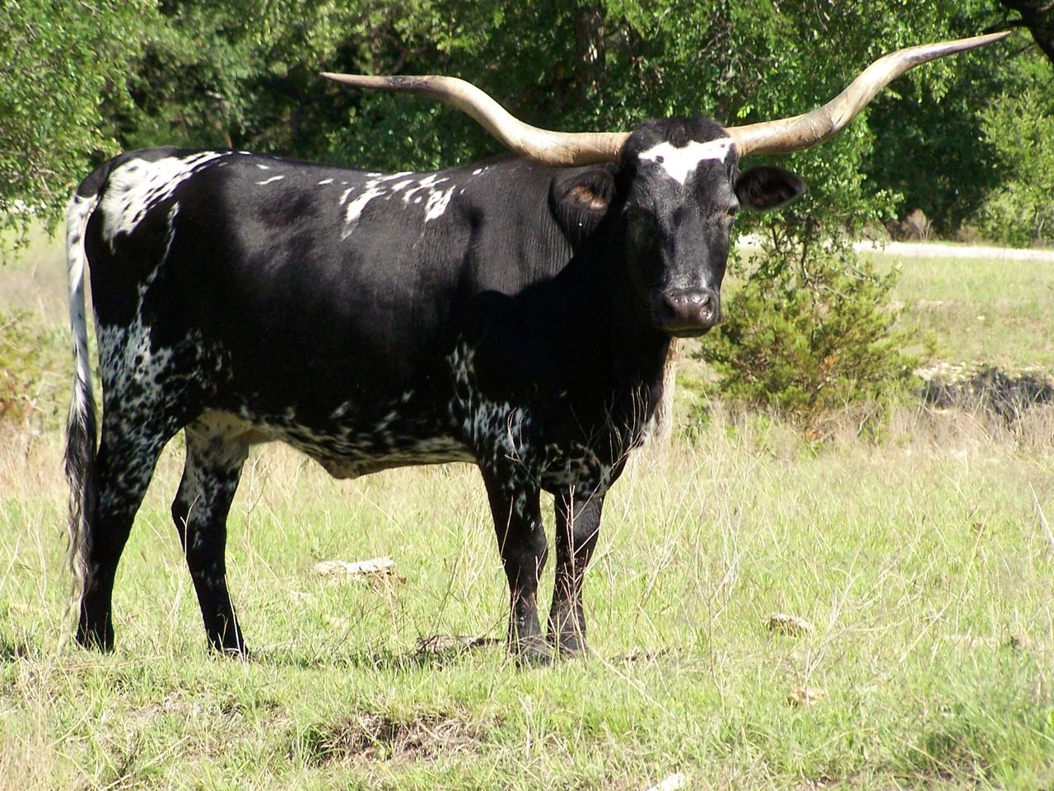
Horn – Are they of good length and shape? Horn is a must--after all this breed is the Texas Longhorn. Horn is not the most important trait and the reason why it is lower on the list. You can have the longest horn cow in the breed but if she has defects then you don’t have much in my opinion except a shoulder mount to hang on your wall.

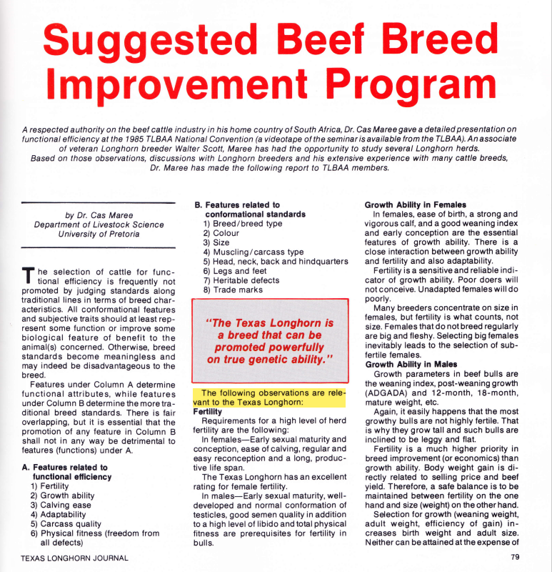
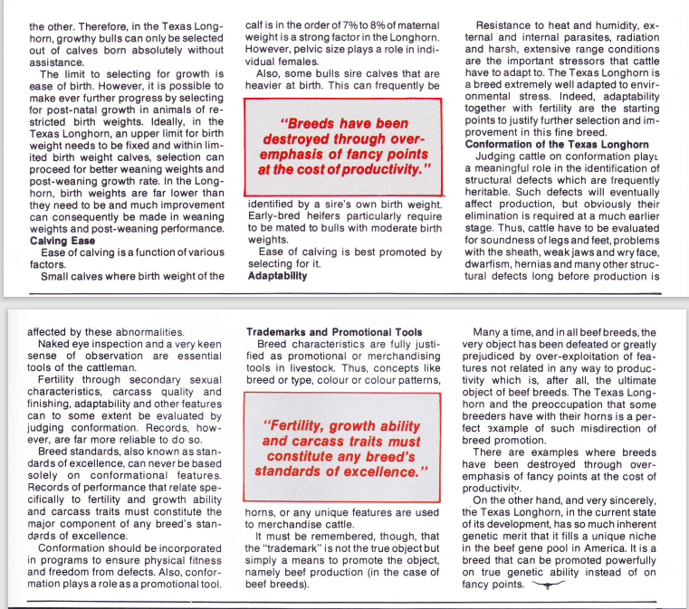
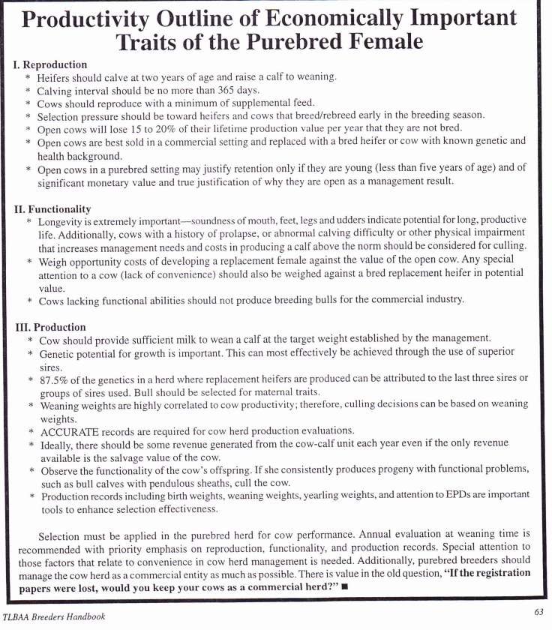
Texas Longhorn Nutrition info
Texas Longhorn cattle are known for being able to survive in the harshest of conditions. With that being said , Longhorn cattle can survive on anything but only thrive when they are provided a consistent and complete diet . Longhorns need a good mineral program in order for their system to process their feed. Consistent dry matter intake paired with adequate crude protein , crude fat ,and mineral is key to their ability to process feed. Additional protein and energy are often required to properly balance diets for growing cattle and lactating cows on forage-based diets. This is especially true when low quality stored forages are the majority of the diet, as is often the case during the winter hay feeding period after a poor hay production season or with hay produced under low levels of management.
Limiting dry matter intake on poor quality forages is another concern with regard to the crude protein content of the diet. Generally, forage dry matter intake as a percent of body weight increases until forage crude protein content as a percentage of dry matter decreases below a threshold of about eight percent. Thus, if a minimum of eight percent crude protein is not maintained in forage crops, cattle will decrease consumption of these poor quality forages. When crude protein is below eight percent, rumen bacteria responsible for digesting forage cannot maintain adequate growth rates. Forage intake and digestibility will then decrease. Crude protein supplements are appropriate under these conditions to stimulate forage intake. Forages with adequate levels of crude protein will not require protein supplementation to improve intake but may need crude protein supplementation if cattle nutrient requirements for crude protein are not being met by the forage alone. Occasional graining or supplementing of cattle disturbs the balance of their digestive system resulting in a 2 to 3 day recovery time. For feed efficiency, digestive health , and desired results consistency is key .Start with small amounts and gradually increase amounts until desired levels of nutrients are achieved . A good rule of thumb for starting cattle on grain or increasing amount of grain is to add a pound a day until the nutritional requirements are met.
Young, growing cattle in particular, need relatively high levels of crude protein in their diets to support muscle growth. Creep feeds or forages for nursing calves should contain at least 15 percent crude protein.
High-protein creep feeds are best used when forage availability is abundant. Average daily gains in nursing calves tend to increase with increasing crude protein content of creep diets, but expense of the diet will likely also increase with increasing protein levels.
Longhorn cattle from birth until weaning, nursing and on 52% or greater TDN forage will grow best on a creep feed that is 22% crude protein , 2%-3% crude fat, and 11%-12% fiber.
Longhorn cattle 7 months to 13 months on 52% or greater TDN forage require 15%-18% crude protein , 2%-3% crude fat , and 11%-12% fiber.
Longhorn cattle 14 months to 30 months on 52% or greater TDN forage require 12%-15% crude protein , 2%-3% crude fat , and 11%-12% fiber.
Longhorn cattle 30 months and older on 52% or greater TDN forage will maintain a body score of 6 when there total diet is 11%-13% crude protein and 2%-3% crude fat
Forage Type and Maturity | Stage of Production | Forage Dry Matter Intake Capacity (% of body weight)
Low quality forage (< 52% total digestible nutrients) | Non-lactating | 1.8
 | Lactating | 2.2
Average quality forage (52 to 59% total digestible nutrients) | Non-lactating | 2.2
 | Lactating | 2.5
High quality forage (> 59% total digestible nutrients) | Non-lactating | 2.5
 | Lactating | 2.7
Lush, growing pasture | Non-lactating | 2.5
 | Lactating | 2.7
Silage | Non-lactating | 2.5
 | Lactating | 2.7

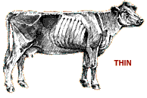

- Bone structure of shoulder, ribs, back, hooks and pins are sharp to the touch and easily visible. No evidence of fat deposits or muscling. Cattle in this condition are weak, near death and have trouble standing or walking.
2 No evidence of fat deposition and muscle loss in the hindquarters. The spinous processes feel sharp to the touch. The spinous processes and the spaces between them are easily seen.
3 Very little fat cover over the loin, back and fore-ribs. The backbone is still highly visible. Processes of the spine can be identified individually by touch and ma still be visible. Spaces between the processes are less pronounced.

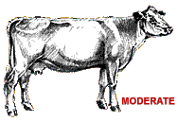
4 Fore-ribs and 12th and 13th ribs are still noticeable to the eye. The transverse spinous processes can be identified only by palpation (with slight pressure) and feel rounded rather than sharp.
5 The 12th and 13th ribs are slightly visible to the eye. The transverse spinous processes can only be felt with firm pressure and feel rounded but are not noticeable to the eye. Spaces between the processes are not visible and are only distinguishable with firm pressure. Areas on each side of the tailhead and the fore-rib, behind the shoulder are starting to fill.
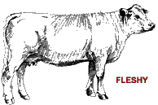
6 Ribs are fully covered and are not noticeable to the eye. Hindquarters are plump and full. Noticeable springiness over the fore-ribs and on each side of the tailhead. Firm pressure is now required to feel the transverse processes. Brisket has some fat.
7 Ends of the spinous processes can only be felt with very firm pressure. Spaces between processes can barely be distinguished. Abundant fat cover on either side of the tailhead with evident patchiness. Fat in the brisket.
8 Animal takes on a smooth, blocky appearance. Bone structure disappears from sight. Fat cover is thick and spongy and patchiness is likely. Brisket is full.
9 Bone structure is not seen or easily felt. The tailhead is buried in fat. The animal's mobility may actually be impaired by excessive fat.

Basic items to have on hand for cattle
- assortment of syringes and needles. 12Ml and 16gauge 1” needles are a common use size
- For my calves we keep NUFLOR on hand. This is a prescription antibiotic, but it may not be necessary to have on hand, its just my go to drug. Its great for most types of scours and respiratory issues.
- Permytherin, this is a bug killer. You can mix it and soak your animal or mix it into a spray. It works great on flies, but also will help treat lice.
- Vet wrap, you never know when you might need it.
- Old towels or blankets, I especially like these during calving season
- pill pusher, I don't know the technical name, but its to administer boluses or pills to cattle. Comes in a couple of sizes, I only have the small calf one, but its not great for the cows! Its plastic and they like to bite it!
- Myloxican, this is a prescription pain/inflammation pill that works great. Aspirin also works and is easier to get.
- Force feeder, this is for drenching calves or force feeding fluids
- BOSE, I get this from my vet. Its a selenium and Vitamin E shot. Its good if you have calves in cool, wet weather or if they have any scours or sickness. Its also good if your calves have weak joints at birth.
- Vitamin B12, if you have a sick or sluggish calf, this is a good pick me up. Especially nice if you have an off season or bad weather birth.
- Powdered Colostrum, ALWAYS have this on hand during calving season!! If you have to go get some, its too late!! If you're worried about storing, you can freeze it.
- Calf bottle 2 quart with a good calf nipple, available at TSC or Family Farm and Home
- Thermometer, you never know when you need it! Rectal is best

Vaccination schedule:
- These can be purchased online from Valley Vet, Jeffers or Animart. They can also be ordered directly from your vet. Remember to always keep them cold and do overnight shipping if you order online!
- calves at weaning
  - Wean calves at approximately 6 months or at least 2 months before mom is due to calve again. To avoid extra stress on calves, wean for 2 weeks before branding.
  - Bovishield Gold with Lepto, this is a modified live vaccination and I don't recommend giving this to bred cattle. It has the potential to cause abortions. Its also a vaccine that must be used with in 24 hours of opening. They will need a booster after 2 weeks, the instructions are on the label. Must be refrigerated.
  - Ultra Bac 7 or Ultra Choice 7: this is a killed vaccination and has an expiration date. It doesn't require mixing so will keep in the refrigerator until expiration date. This will also require a booster shot, follow label instructions. One method is to give first shot a week before weaning, followed by the booster after the calf is weaned according to label instructions for amount of time. Another method is to give first shot after calf has been weaned for 2 weeks and stress of weaning is not longer an issue.
  - Weaned heifers need to be Brucellosis vaccinated. This needs to be done by a licensed vet some time between 4 months and 1 year of age. This is what is called OCV'd or official calf vaccinated. Michigan is Brucellosis free, but for shows and sale out of state, this is a must!! Bull calves CAN NOT have the Brucellosis vaccine.
- Bred heifers and mature cattle
  - Cattle Master Gold with Lepto, this is a killed vaccine. It is labeled safe for pregnant animals. This one is a mix vaccine and needs to be used with in 24 hours of opening or its no good.
  - Ultra Choice 7 or Ultra Bac 7, same as the vaccine for the calves. Either of these are fine. My vet says there is the potential for more of an injection site reaction with the Ultra Bac 7. I have not noticed a difference and have used both products. So that is at your discretion. They fight against the same diseases.
  - Cattle that live in areas prone red water should be vaccinated with Ultra 8, which is the the Ultra 7 but with Red Water.

You should always consult your vet to make sure you are completing the vaccines that are best for your region!!

Parasite Control:
- Every fall after the first frost the cattle need a de-worming treatment. It is crucial to switch medications at least yearly, if not every treatment. This helps prevent the parasites from becoming immune. Currently Ivermectine based wormers are not very effective.
- Every Spring as the grass is starting to grow your cattle will need another de-worming treatment. You can choose to do Cydectin or choose an injectable or paste. Eprinex is a good option if you're really concerned you can take fecal samples to your vet for testing to see how your parasite control is working.
- LONGRANGE: this is a prescription worm treatment. Its very costly but works great and lasts up to 3 months. Its great to give to cattle that have problems with worms. We use it in pastures that are hard to catch and treat. It works great in the summer to break the life cycle in worms. It can also only be given to steers or females. It has been noted that it can cause temporary sterility in bulls!
- Occasionally if you bring cattle up from the south, they could come with Liver Flukes. These are hard to kill and are hard on the cows. Ivermectin Plus inject able works the best and seems to kill them off.
- Lice control becomes necessary late fall/early winter. Clean Up II is a good product to apply for this. We generally treat the first time in late December or January if we don't use a pour on dewormer. Typically if lice are present, a repeat treatment could be necessary as often as every 28 days. Dust, vet gun balls and permytherin all help in the control of lice. Ultra Boss is another good product.

